ITA0601 – MACHINE LEARNING
LAB EXPERIMENTS
EXP-13: Car Price Prediction Model using Python
Dataset 1 – Car Price Prediction
Year | Mileage (km) | Engine (cc) | Owners | Price (Lakhs)
2015 | 80000 | 1200 | 2 | 4.5
2016 | 70000 | 1200 | 1 | 5.2
2017 | 60000 | 1500 | 1 | 6.8
2018 | 50000 | 1500 | 1 | 7.5
2019 | 40000 | 1600 | 1 | 9.0
2020 | 30000 | 1600 | 1 | 10.5
2021 | 25000 | 1800 | 1 | 12.0
2022 | 18000 | 1800 | 1 | 14.0
2023 | 10000 | 2000 | 1 | 16.5
2024 | 5000 | 2000 | 1 | 18.5

Python Code:
import pandas as pd
from sklearn.linear_model import LinearRegression
data = {
"Year": [2015, 2016, 2017, 2018, 2019,
2020, 2021, 2022, 2023, 2024],

"Mileage": [80000, 70000, 60000, 50000, 40000,
30000, 25000, 18000, 10000, 5000],

"Engine": [1200, 1200, 1500, 1500, 1600,
1600, 1800, 1800, 2000, 2000],

"Owners": [2, 1, 1, 1, 1, 1, 1, 1, 1, 1],

"Price": [4.5, 5.2, 6.8, 7.5, 9.0,
10.5, 12.0, 14.0, 16.5, 18.5]
}
df = pd.DataFrame(data)
X = df[["Year", "Mileage", "Engine", "Owners"]]
y = df["Price"]
model = LinearRegression()
model.fit(X, y)
new_car = pd.DataFrame({
"Year": [2022],
"Mileage": [20000],
"Engine": [1800],
"Owners": [1]
})
prediction = model.predict(new_car)
print("Predicted Car Price:", round(prediction[0], 2), "Lakhs")
Output:
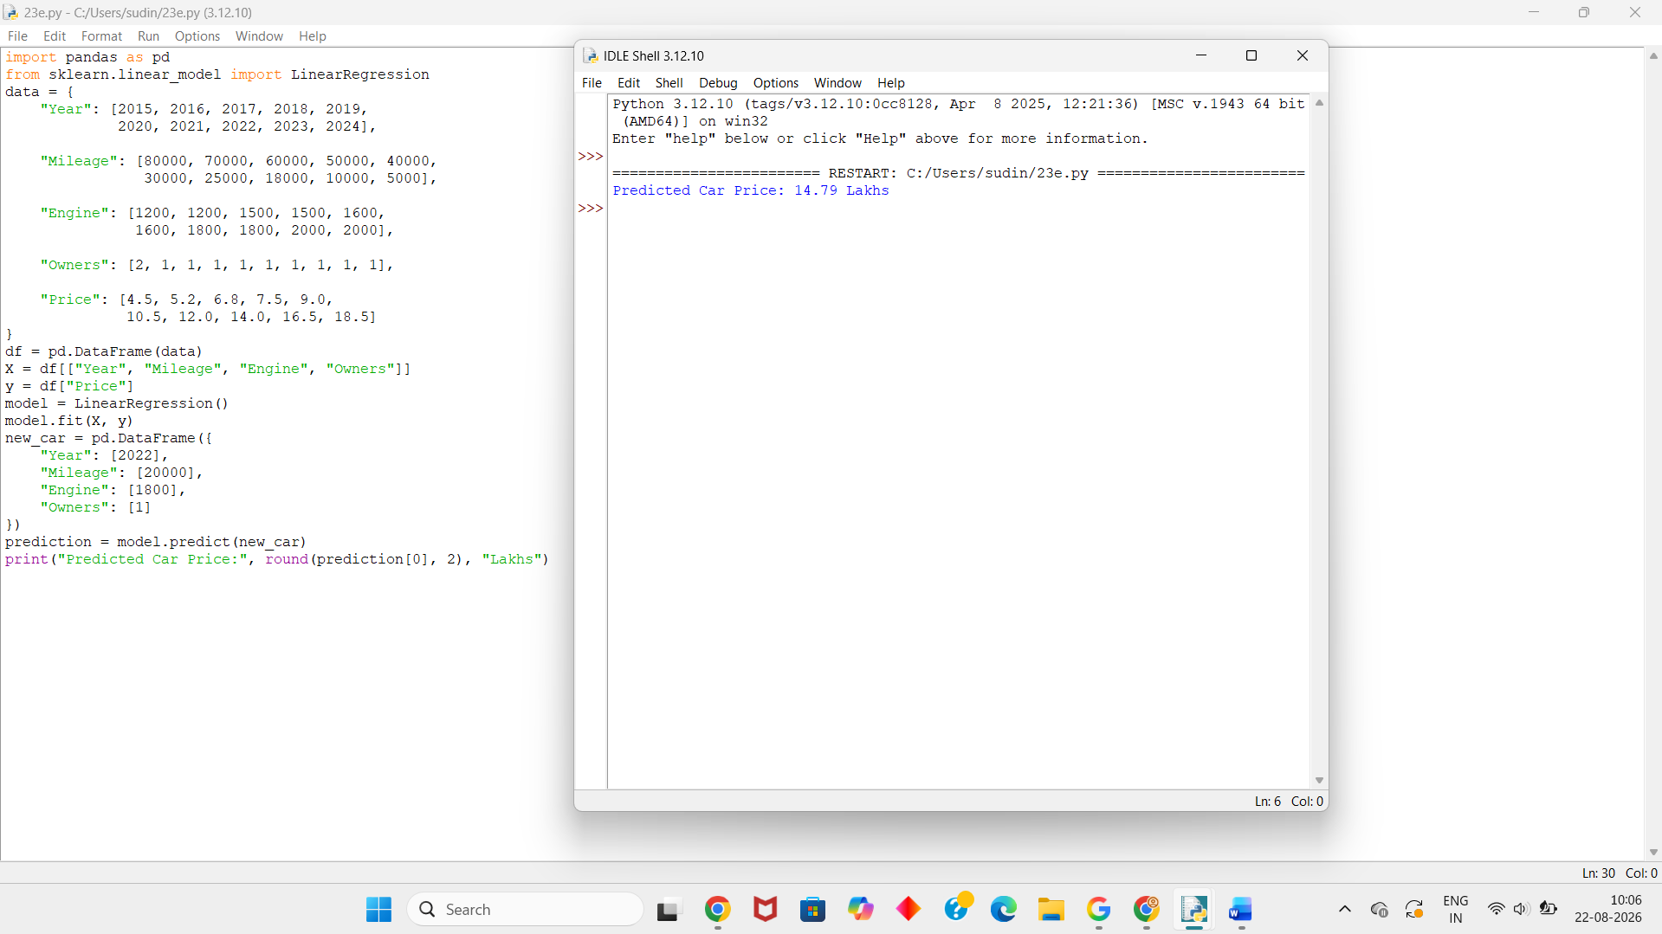
Dataset 2 – Car Price Prediction
Year | Mileage | Engine | Owners | Price
2014 | 90000 | 1000 | 3 | 3.2
2015 | 85000 | 1100 | 2 | 3.8
2016 | 75000 | 1200 | 2 | 4.5
2017 | 65000 | 1300 | 2 | 5.3
2018 | 55000 | 1400 | 1 | 6.4
2019 | 45000 | 1500 | 1 | 7.5
2020 | 35000 | 1500 | 1 | 8.8
2021 | 25000 | 1600 | 1 | 10.2
2022 | 15000 | 1800 | 1 | 12.5
2023 | 8000 | 1800 | 1 | 14.5
Python Code:
import pandas as pd
from sklearn.linear_model import LinearRegression
data = {
"Year": [2014, 2015, 2016, 2017, 2018,
2019, 2020, 2021, 2022, 2023],

"Mileage": [90000, 85000, 75000, 65000, 55000,
45000, 35000, 25000, 15000, 8000],

"Engine": [1000, 1100, 1200, 1300, 1400,
1500, 1500, 1600, 1800, 1800],

"Owners": [3, 2, 2, 2, 1, 1, 1, 1, 1, 1],

"Price": [3.2, 3.8, 4.5, 5.3, 6.4,
7.5, 8.8, 10.2, 12.5, 14.5]
}
df = pd.DataFrame(data)
X = df[["Year", "Mileage", "Engine", "Owners"]]
y = df["Price"]
model = LinearRegression()
model.fit(X, y)
new_car = pd.DataFrame({
"Year": [2020],
"Mileage": [30000],
"Engine": [1500],
"Owners": [1]
})
prediction = model.predict(new_car)
print("Predicted Car Price:", round(prediction[0], 2), "Lakhs")
Output:
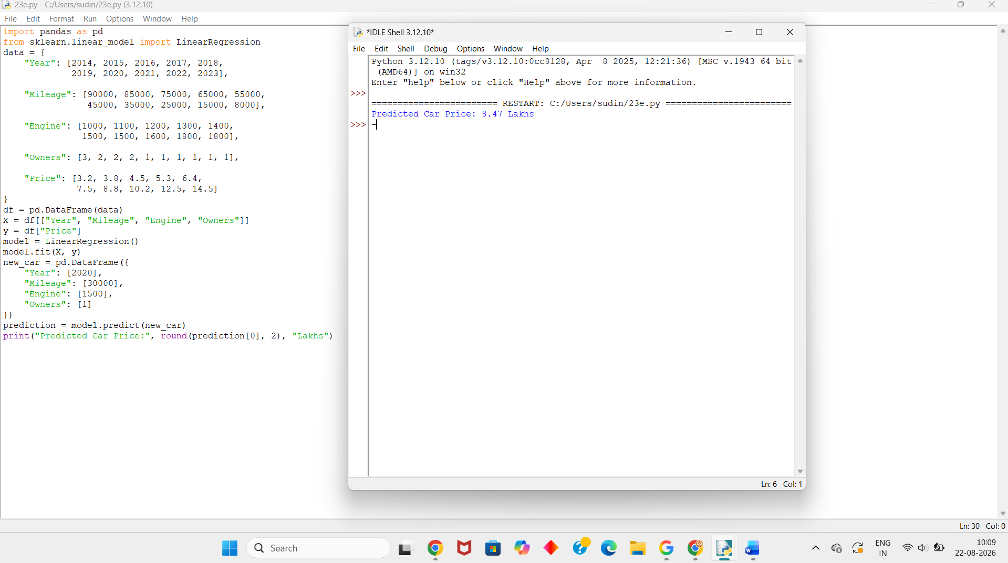
Dataset 3 – Car Price Prediction
Year | Mileage | Engine | Owners | Price
2013 | 100000 | 1000 | 3 | 2.8
2014 | 95000 | 1100 | 3 | 3.1
2015 | 80000 | 1200 | 2 | 4.0
2016 | 70000 | 1300 | 2 | 4.8
2017 | 60000 | 1400 | 2 | 5.5
2018 | 50000 | 1500 | 1 | 6.5
2019 | 40000 | 1600 | 1 | 7.8
2020 | 30000 | 1600 | 1 | 9.0
2021 | 20000 | 1800 | 1 | 11.0
2022 | 10000 | 2000 | 1 | 13.5
Python Code:
import pandas as pd
from sklearn.linear_model import LinearRegression
data = {
"Year": [2013, 2014, 2015, 2016, 2017,
2018, 2019, 2020, 2021, 2022],

"Mileage": [100000, 95000, 80000, 70000, 60000,
50000, 40000, 30000, 20000, 10000],

"Engine": [1000, 1100, 1200, 1300, 1400,
1500, 1600, 1600, 1800, 2000],

"Owners": [3, 3, 2, 2, 2, 1, 1, 1, 1, 1],

"Price": [2.8, 3.1, 4.0, 4.8, 5.5,
6.5, 7.8, 9.0, 11.0, 13.5]
}
df = pd.DataFrame(data)
X = df[["Year", "Mileage", "Engine", "Owners"]]
y = df["Price"]
model = LinearRegression()
model.fit(X, y)
new_car = pd.DataFrame({
"Year": [2019],
"Mileage": [35000],
"Engine": [1600],
"Owners": [1]
})
prediction = model.predict(new_car)
print("Predicted Car Price:", round(prediction[0], 2), "Lakhs")
Output:
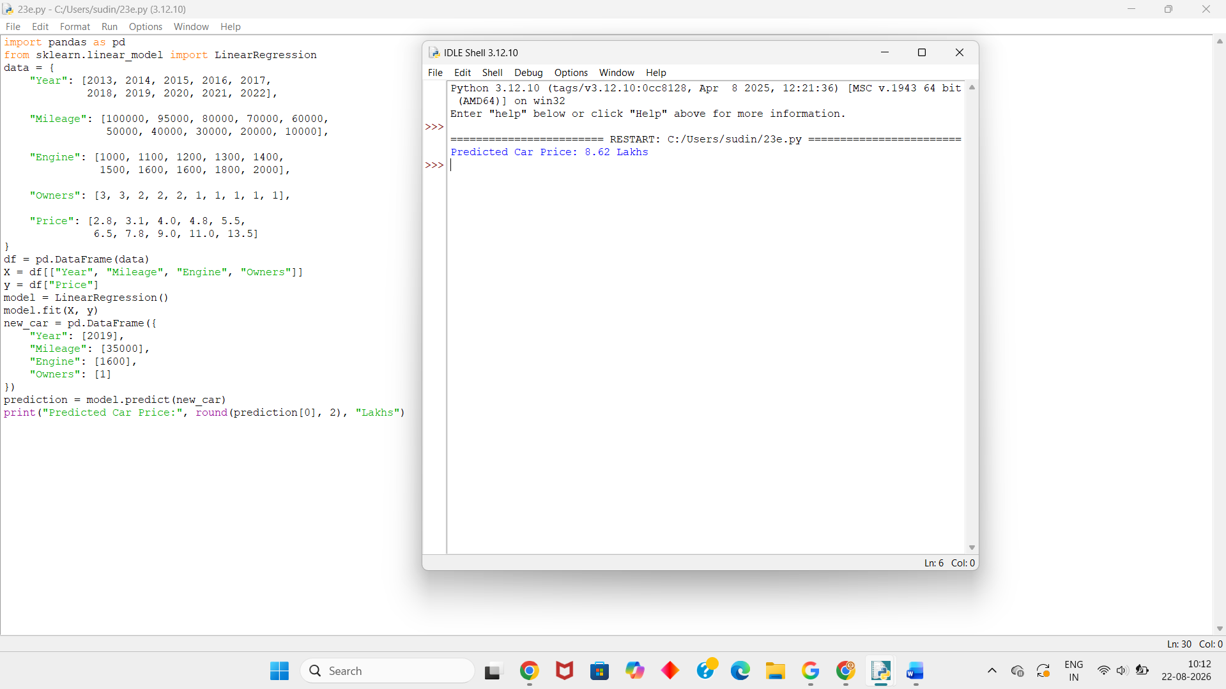
Dataset 4 – Car Price Prediction
Year | Mileage | Engine | Owners | Price
2016 | 75000 | 1200 | 2 | 4.8
2017 | 68000 | 1300 | 2 | 5.5
2018 | 58000 | 1400 | 1 | 6.7
2019 | 48000 | 1500 | 1 | 7.8
2020 | 38000 | 1600 | 1 | 9.2
2021 | 28000 | 1700 | 1 | 11.0
2022 | 20000 | 1800 | 1 | 13.0
2023 | 12000 | 1900 | 1 | 15.2
2024 | 7000 | 2000 | 1 | 17.5
2025 | 3000 | 2200 | 1 | 20.0
Python Code:
import pandas as pd
from sklearn.linear_model import LinearRegression
data = {
"Year": [2016, 2017, 2018, 2019, 2020,
2021, 2022, 2023, 2024, 2025],
"Mileage": [75000, 68000, 58000, 48000, 38000,
28000, 20000, 12000, 7000, 3000],
"Engine": [1200, 1300, 1400, 1500, 1600,
1700, 1800, 1900, 2000, 2200],
"Owners": [2, 2, 1, 1, 1, 1, 1, 1, 1, 1],
"Price": [4.8, 5.5, 6.7, 7.8, 9.2,
11.0, 13.0, 15.2, 17.5, 20.0]
}
df = pd.DataFrame(data)
X = df[["Year", "Mileage", "Engine", "Owners"]]
y = df["Price"]
model = LinearRegression()
model.fit(X, y)
new_car = pd.DataFrame({
"Year": [2023],
"Mileage": [10000],
"Engine": [1900],
"Owners": [1]
})
prediction = model.predict(new_car)
print("Predicted Car Price:", round(prediction[0], 2), "Lakhs")
Output:
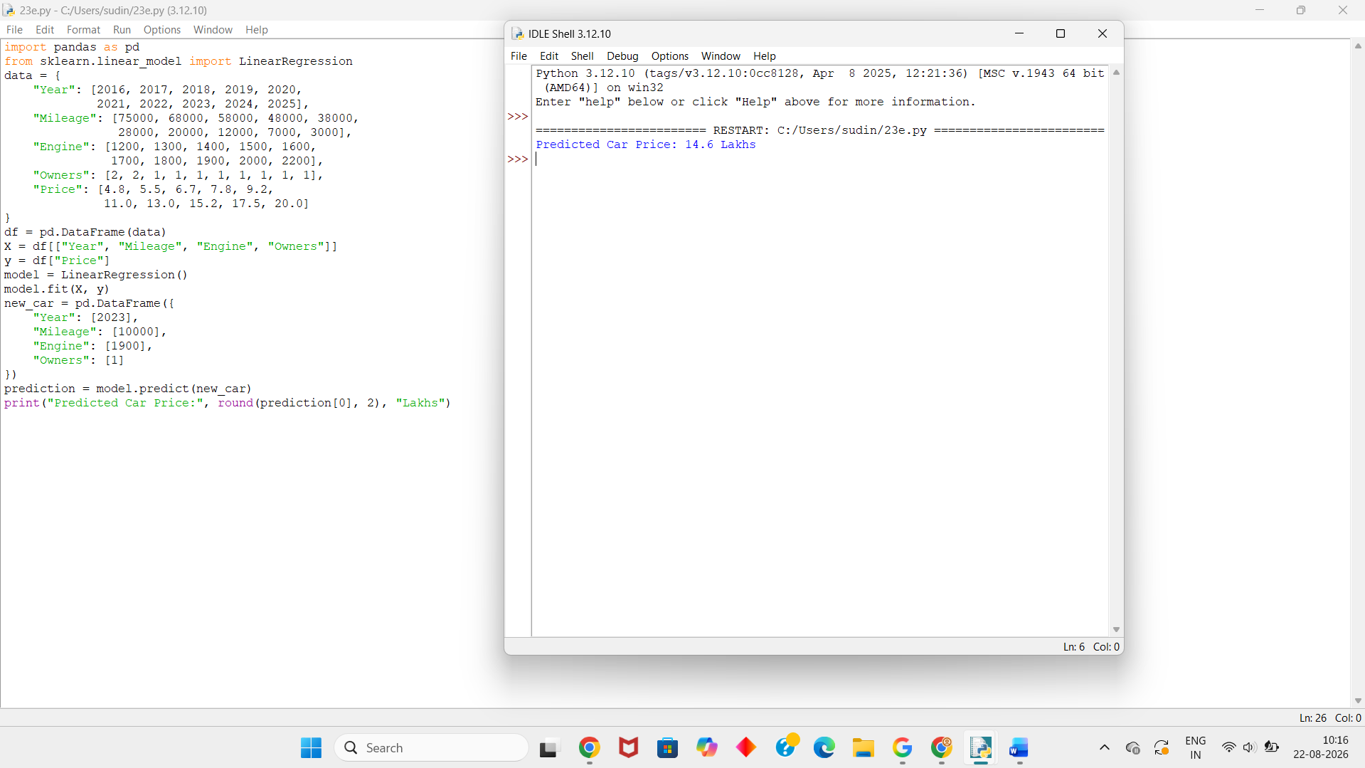
Dataset 5 – Car Price Prediction

Year | Mileage | Engine | Owners | Price
2015 | 88000 | 1100 | 3 | 3.5
2016 | 76000 | 1200 | 2 | 4.4
2017 | 65000 | 1300 | 2 | 5.2
2018 | 54000 | 1400 | 2 | 6.2
2019 | 43000 | 1500 | 1 | 7.4
2020 | 32000 | 1600 | 1 | 8.9
2021 | 24000 | 1700 | 1 | 10.5
2022 | 16000 | 1800 | 1 | 12.8
2023 | 9000 | 1900 | 1 | 15.0
2024 | 4000 | 2000 | 1 | 17.8
Python Code:
import pandas as pd
from sklearn.linear_model import LinearRegression
data = {
"Year": [2015, 2016, 2017, 2018, 2019,
2020, 2021, 2022, 2023, 2024],
"Mileage": [88000, 76000, 65000, 54000, 43000,
32000, 24000, 16000, 9000, 4000],
"Engine": [1100, 1200, 1300, 1400, 1500,
1600, 1700, 1800, 1900, 2000],
"Owners": [3, 2, 2, 2, 1, 1, 1, 1, 1, 1],
"Price": [3.5, 4.4, 5.2, 6.2, 7.4,
8.9, 10.5, 12.8, 15.0, 17.8]
}
df = pd.DataFrame(data)
X = df[["Year", "Mileage", "Engine", "Owners"]]
y = df["Price"]
model = LinearRegression()
model.fit(X, y)
new_car = pd.DataFrame({
"Year": [2021],
"Mileage": [20000],
"Engine": [1700],
"Owners": [1]
})
prediction = model.predict(new_car)
print("Predicted Car Price:", round(prediction[0], 2), "Lakhs")

Output:
